ECE 210 Lab 7 – PCB Soldering

# Overview

In this lab, you will solder components to your printed circuit board (PCB) in order to turn it from a piece of plastic into a power adapter and motor controller board.

You will need

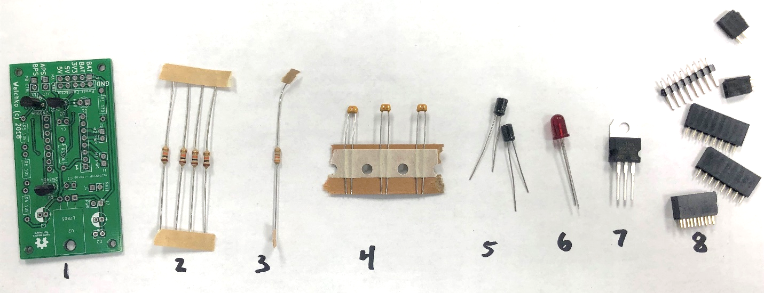

1. PCB board (with 2 x transistors and 1 x 3.3 V voltage regulator already soldered on)
2. 4 x 10 kΩ resistors
3. 1 x 330 Ω resistor
4. 3 x 0.1 µF capacitors
5. 2 x 10 µF capacitors
6. 1 x red LED
7. 1 x 5 V voltage regulator
8. Headers
   1. 1 – 2x5 female
   2. 2 – 8x1 female
   3. 2 – 2x1 female
   4. 4 – 2x1 male

# Pre-Lab Activities

1. Test to ensure the three pins of the transistors and voltage regulator are not connected using the continuity tester on the digital multimeter (DMM).
2. Make sure the LED works by inserting it into your Arduino between digital pin 13 and GND and running your LED lab (example 1).

# Starting Point

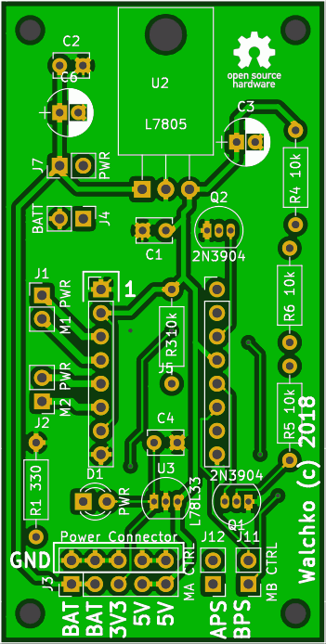

This is the PCB with all of its component labels. The transistors (3-pin components represented by a circle with a flattened side) may have been soldered in for you. If not, start with those.

1. Solder all 5 resistors into the board. It is highly recommended to use a digital multimeter to double-check the resistances of each resistor. Additionally, recognize that the resistor in the center of the board is R3, with a value of 10 kΩ (NOT 310 kΩ). To save time, identify and place all of the resistors before soldering them (you can bend their pins on the backside of the board to hold them in place temporarily).
   1. R1: 330 Ω
   2. R3: 10 kΩ
   3. R4: 10 kΩ
   4. R5: 10 kΩ
   5. R6: 10 kΩ
2. Next, solder the 3 smaller, orange capacitors into the C1, C2, and C4 spots on the board. By this point, the board should look like this (with the transistors):

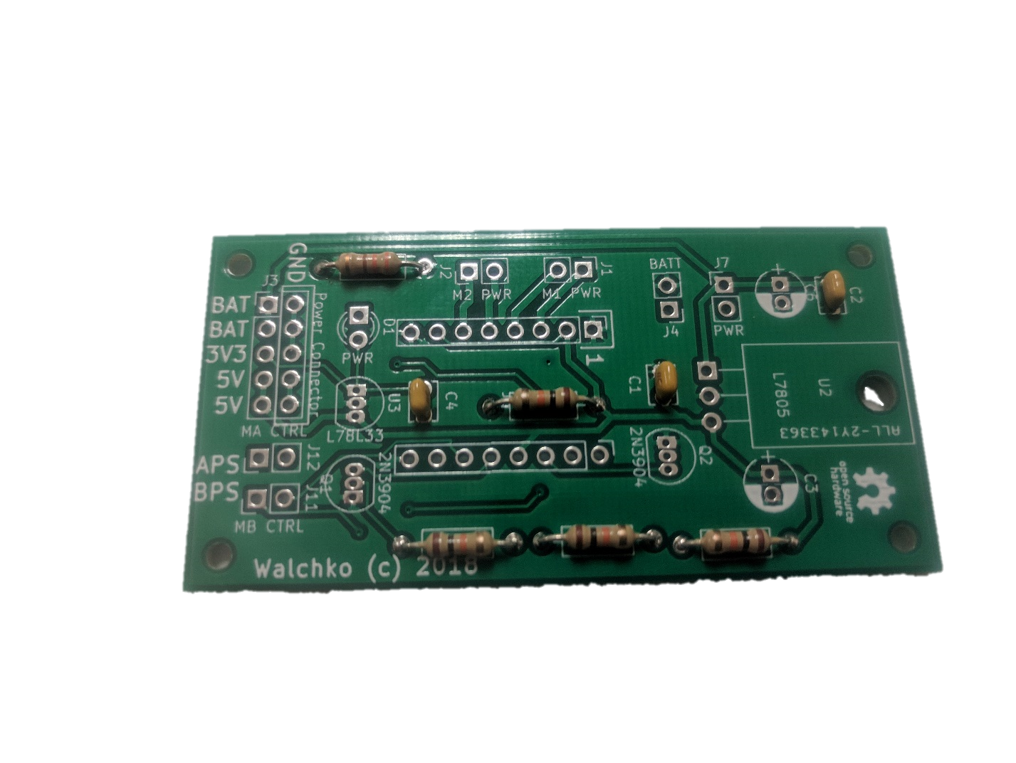

1. Attach the 2 electrolytic capacitors next (taller cylindrical ones). Their polarity does matter, so use the labelling on both the capacitors and the PCB to ensure you don’t fry them.
2. Solder on the red LED. Again, its polarity matters, so remember that the longer pin will be the positive terminal, and the slightly flattened edge of the bulb corresponds to the negative terminal. By now your board should look like this:

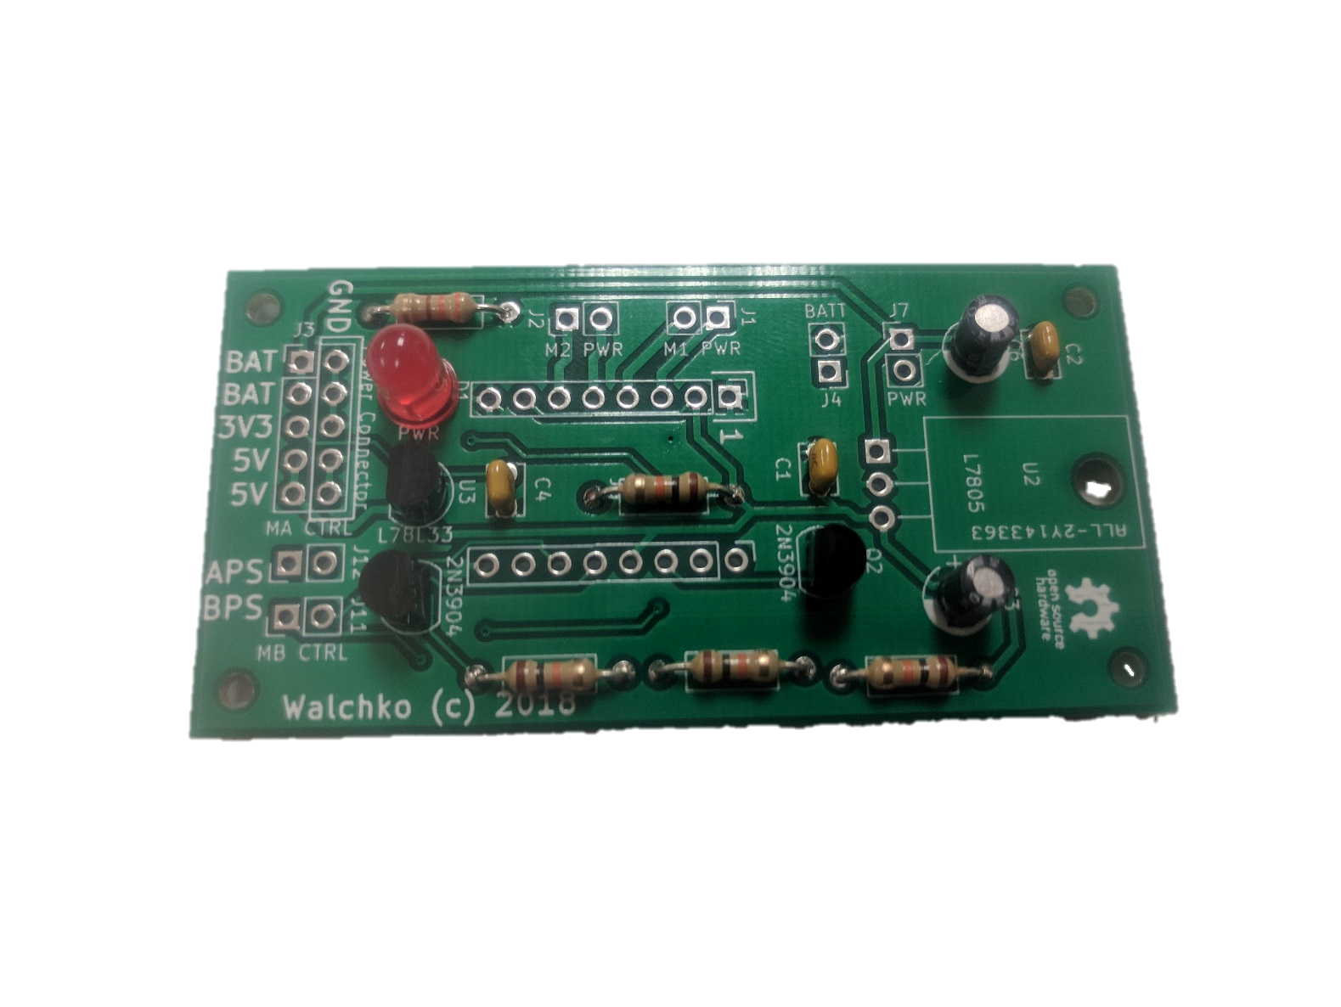

1. Solder in the voltage regulator chip (3-pins, largest one you have). Bend it back so that it fits roughly into the box drawn on the PCB.
2. At this point, all that is left are the attachment points for the leads from the Arduino, battery pack, motors, and power switch. The 2x5 block of connections nearest the LED should all be female connectors, as well as the 2 motor connections and the 2 8x1 blocks in the center of the board for the motor driver chip. The others (APS, BPS, Batt, and PWR) are male connectors. It helps to use tape to hold the connectors in place while you solder them.
3. Finally, plug in the motor driver chip to the two central 1x8 female connectors. It should be oriented so that the silver-ish small capacitor is faced towards the voltage regulator. Reference the below image of the completed circuit to ensure you get this right.

